BSC – HGP – Project Go

UI Design Document & Report

# Division of Work

Student Name1: Yannick Brandt Student Number1: 3077620

Student Name2: Emma Nyaguthii Karanja Student Number2: 3027657

Division of work: Since our experience levels are pretty different, I (Yannick) did a bit more of the coding in the project

______________________________________________________________________

## Code repository log (if applicable)

See git log

## Percentage of work completed by each partner on each class / task

Some areas require more work than others so this is only for reference. An average of these values will not be calculated.

|  |  |  |
| --- | --- | --- |
| **Task** | **Yannick Brandt** | Emma Nyaguthii Karanja |
| 1 Board | 100% | 0% |
| 2 Menus/Buttons/labels | 60% | 40% |
| 3-7 Placement | 100% | 0% |
| 8 Winner | 90% | 10% |
| 9 Analysis / Timer / handicap | 90% | 10% |
| 10 Documentation | 95% | 5% |
| UML Diagram | 70% | 30% |
| Design Mockup | 60% | 40% |

# UI Design

**Submission:** Edit this template and submit it as part of your submission.

**Length**: Should be 4 pages approx. Word count is flexible, but all decisions should be clarified.

To achieve good marks in this item ensure that this document is well structured and addresses each of the following headings and subheading. The explanation of each UI Design Choice should be clear, precise and show substantial consideration has been made, references are welcome. All decisions should be explained regardless of how basic they are. Do not cut and paste justification from the internet (plagiarism) or notes but include references and explanations in your own words where appropriate.

**Student Names:** Yannick Brandt, Emma Nyaguthii Karanja

* Include multiple screen shots of the application each focusing on a different component clearly labelled
* Clearly indicate what is working and what is not.
* Discuss each component under the following headings
* Location: e.g. The button was placed in the bottom right to as it is the default location to confirm and action
* Colour: The colour scheme was chosen to avoid the main form of colour blindness and produce high contrast for the visually impaired.
* Size:
* Style:
* Etc.

**N.B.** Clearly mention any additional features here either visual or functional so that appropriate marks are awarded

## Overview­

GoGoGo is a basic application to play go. The two human players can configure the rules, play the game, and analyze all played moves afterwards.

The UI Design decisions made during the development of the application are justified in this document. A big influence for [color](https://material.io/design/color/the-color-system.html#tools-for-picking-colors) and [iconography](https://fonts.google.com/icons?selected=Material+Icons) was the [material design system](https://material.io/) which is the recommended design toolbox from google. Another influence were the seven gestalt principles #figure_ground, #similarity, #proximity, #common_fate, #continuity, #closure and #symmetry. In general, the UI is trying to be #responsive, #intuitive, #clear, #informative and #forgiving.

Common widgets like buttons, labels etc. were intentionally modified as little as possible to ensure visual consistency with other application on the users’ operating system.

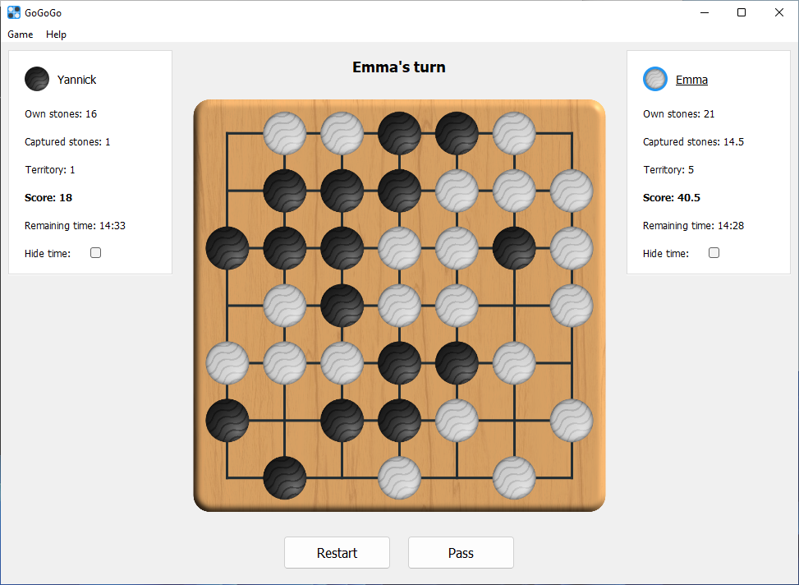

Figure 1: GoGoGo main window

## Screen Shots of Working/Not Working Features

This section describes each component under the aspect of location color size, style, and extras.

All features are fully working and tested on Windows 10/11 and macOS Catalina/Big Sur.

|  |  |
| --- | --- |
| Task 1 Board | |
| Figure 2: Board | **Location**:The go board is the most important widget in the application. That’s why it takes the central position in application. Centering the board also helps to keep #visual_balance in the main window and reduce visual complexity due to #symmetry. |
| **Color:** Original go is played with white and black stones. To prevent confusion these “colors” are also chosen for the application. The physical board is usually made from wood which is also chosen for the digital board coloring. The #similarity to physical go should help players who played go in the real world before to understand the digital version. |
| **Size:** The board takes up the most amount of space in the main window and fills extra available space when the window size increases. The size really draws attention to the board when the game is started. |
| **Style:** The whole board is generally designed to match the physical one as closely as possible. This includes lighting effects on the board and stones and a wood texture on the board.  The only deviation from physical boards are the rounded corners to match the general application style and they also seem to be [easier on the eye](https://uxmovement.com/thinking/why-rounded-corners-are-easier-on-the-eyes/). |
| **Extras:** |

|  |  |  |
| --- | --- | --- |
| Task 2 Menus / Buttons / Labels | | |
| 2a Tutorial | | |
| Figure 4: Board | **Location**:The tutorial is a separate window that can be accessed through the menu or a button on the configuration screen. This allows experienced players to easily skip this step, but it is always available for newcomers. | |
| **Color:** The text color is kept default for #consitency with the user’s operating system. The Next button is active (has a blue border around it) to indicate the default action. | |
| **Size:** The headline is bigger than the description for each tutorial step to show #visual_hierarchy. The next button is also bigger than the back button to guide the user through the tutorial. | |
| **Style:** Important information in the description is bolt to emphasize it. The description of each step is also kept as short as possible to keep the user’s attention. | |
| **Extras:** During the tutorial, there are sections where the user hast to click on a highlighted field to place a stone. This makes the tutorial interactive and keeps the user’s attention. | |
| 2b-c Prisoners / Territory | | |
| Figure 5: Player widget | | **Location**:Each player’s information i.e. (icon, name, captured stones, territory, and his/her time) is located either to the most right or most left to clearly make a distinction of the two players. The users’ names and the icons are located at the top since they are useful information that the user can easily associate themselves with. |
| **Color:** Black and white icons were used for the users to easily distinguish between the players. Black text was used on a white background to increase the contrast and make the font visible. White background against the grey window background to group all the user’s information together. |
| **Size:** The icon’s size was scaled down fit it next to the player’s name. The score details are slightly bigger and bold for users’ peripheral view to keep track of their progress while still concentrating on the game. |
| **Style:** The player is given the option of hiding the timer to make it less distracting so that he/she can concentrate on the game itself. The font style used was default sans serif to keep it simple and not distracting to the user when interacting with the UI. |
| **Extras:** |
| 2d Whose turn | | |
| Figure 6: Status + player widget | | **Location**:Since information about the current player is critical to both players, it is displayed in two locations. First there is the general status widget located in the prominent place above the board. Second there is a colored ring around the stone and an underline in the respective player widget. |
| **Color:** The ring is the same material design blue as the app icon for #consistency. The status widget label is black for contrast and because it is the default. |
| **Size:** The status widget is bigger than all other fonts in the main window to rank it high in the #visual_hierarchy. |
| **Style:** There were a few iterations until the ring and underline for the player widget were chosen. Other ideas included making the player’s name bold or using a material design drop shadow on the stone. The bold text was scrapped because it changed the label size and caused layout shifts. The drop shadow was just not very visible considering the whole window. |
| **Extras:** |
| 2e-f Pass / Reset | | |
| Figure 7: Game actions | | **Location**:The pass and reset buttons are located just below the board and placed next to each other because they are the two main actions aside from placing a stone on the board. They have a bit of spacing between them to prevent clicking the wrong one. |
| **Color:** The buttons are default white to blend in with the rest of the UI and maintain #consistency with the operating system. |
| **Size:** The buttons are a bit bigger to emphasize the two actions. |
| **Style:** The default font style was used for #consistency. |
| **Extras:** The restart button pops up a modal dialogue box when pressed since it’s a critical event and affects the running game, thus demands attention from the user. |

|  |  |
| --- | --- |
| Task 3-7 Placement | |
| Figure 8: Free fields only    Figure 9: Suicide rule  Figure 10: Capture before    Figure 11: Capture after | **Extras:** Stones can be placed by pressing the left mouse button while hovering over a valid field. I an invalid field (occupied, suicide or KO) is clicked, an animated red cross is shown in the field. Captured stones (single or grouped) are removed from the board (see figure 10,11). |
| **Location**:The hitbox for a field is as big as possible to make the application #forgive slightly wrong mouse positions. |
| **Color:** The cross that shows an invalid move is red to draw attention and indicate a problem. To make this signal also accessible to color blind people the shape is a cross. |
| **Size:** Physical go stones would probably be smaller, but these sizes were chosen by iterating over multiple sizes and choosing what felt right. |
| **Style:** The stones have a slight texture on them. Pure white/black might work for stones placed on the wood-colored board, but the stones are also displayed in the player widget and configuration screen. These have a light gray background and the pattern on the stones make them more visible on these backgrounds. |
|  |

|  |  |
| --- | --- |
| Task 8 Winner (2 image) | |
| Figure 12: Winner | **Location**:After the game ends there are two main actions: analyze and new game. Both actions are easily accessible by two buttons in the center of the window. |
| **Color:** The buttons are kept in their default color for #consistency but the board’s brightness is lowered to increase the contrast between itself and the buttons. |
| **Size:** The buttons are bigger than default to fill the available space and make it easier to hit them. |
| **Style:** The status widget shows the winner complemented by celebrating icons to relax the visual complexity. |
| **Extras:** The general game-end-layout is very similar to the layout before the game ended for #consisency. Only irrelevant actions like pass have been removed. |

|  |  |
| --- | --- |
| Task 9 Additional feature | |
| 9a Analysis view | |
| Figure 13: Analysis | **Location**:The analysis controls are located centered under the board for visual balance and to connect them through the #proximity principle to the board. |
| **Color:** The most important component of the analysis view is the slider to step through the game. This slider is active (blue) and thus the #focal_point of the window. |
| **Size:** The new game button is bigger to make it stand out as the second most important action after stepping through the game. |
| **Style:** The buttons next to the slider have material design icons instead of text because the icons for next and back are well known by most people and are easy to understand. |
| **Extras:** The back/next buttons are disabled when the first/last step is selected to prevent the user from stepping to far into either direction. |
| 9b Game Configuration | |
| Figure 14: GoGoGo configuration window | **Location**:All inputs are located from top to bottom in the order of importance. The original idea was to have the configuration and game use the same window. The problem was that the window needed to resize when switching from configuration to game and vice versa. It seems not possible (or very difficult) to resize the window to a smaller size when the layout changes. Now the configuration has its own window which is dynamically shown when needed. |
| **Color:** The #focal_point of the window is the blue start game button because it is the main action. The other colors are kept in shades of gray because it is the default and doesn’t distract from the main action button. |
| **Size:** The window is not resizable because there is no benefit of resizing and the layout would just stretch. The start game button is bigger than the tutorial button because it is the main action. |
| **Style:** The individual sections of the form are grouped together using the #proximity principle. The headlines are centered for #visual_balance but the individual labels (“player 1”, “use time limit”) are aligned left for better readability. |
| **Extras:** All menu actions have keyboard shortcuts to enable experienced players to navigate quickly through the application. |